**Tilting sensor specification**

**Version 1.0**

**Date: 09 August 2019**

**CONTENTS**

1. Description of the Inclinometer 3

2. Mechanics and Connections 4

2.1. Mechanical data 4

2.2. Dimensions 5

2.3. Connector 6

3. Absolute Maximum Ratings 7

4. Operating Conditions 7

5. Electrical Characteristics 7

6. Inclinometer Characteristics 7

7. Electrical Interface 8

7.1 Conventions 8

7.2 Source Address 8

7.3 The tilt sensor output when SCL3300 digital sensor is used 8

7.4 The tilt sensor output when RTY180HVNAA analog sensor is used 9

7.5 Address Claim 10

7.6 Address Claim Request 10

7.7 Master Control Commands 11

7.8 Command bytes 11

7.9 Response message to Request for Identity number command 13

7.10 Response message to Request for commands except Identity number command 13

7.11 Error message 14

7.12 Sensor communication example 14

8. Qualification and test 17

9. Packing 17

10. Additional information 17

# Description of the Inclinometer

The inclinometer is based on a micro machined accelerometer (MEMS) and an analog rotary position sensor.

# Mechanics and Connections

# Mechanical data

|  |  |  |  |  |  |  |
| --- | --- | --- | --- | --- | --- | --- |
| Parameter | Symbol | Conditions | Min | Type | Max | Unit |
| Weight |  |  |  |  |  |  |
| Width |  |  |  |  |  |  |
| Length |  |  |  |  |  |  |
| Height |  |  |  |  |  |  |

# Dimensions

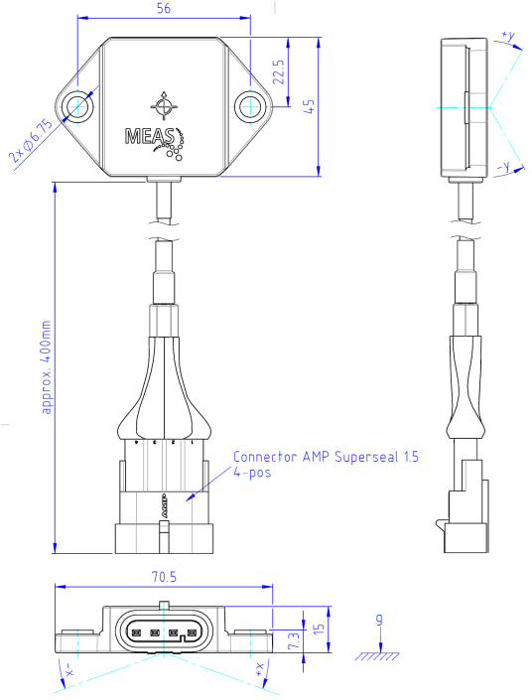

# Connector

The inclinometer has two connectors. One of them, it is called main connector in here, is “**AMP Superseal 1.5 series”** connector with 4 terminals for transferring data to a master device. Another is called sensor connector, to connect the analog sensor.

The pin assignment of the main connector is described below.

|  |  |  |  |  |
| --- | --- | --- | --- | --- |
| Pin | Function | Description | Direction | Color |
| 1 | Supply Voltage | 12V | In | Red |
| 2 | Ground | 0V | In | Black |
| 3 | CAN High | CAN high line | In/out | White |
| 4 | CAN Low | CAN low line | In/out | Green |

The pin assignment of the sensor connector is described below.

|  |  |  |  |  |
| --- | --- | --- | --- | --- |
| Pin | Function | Description | Direction | Color |
| 1 | Supply Voltage | 12V output for sensor supply | Out | Orange |
| 2 | Ground | 0V | Out | Blue |
| 3 | Input | Analog line | In | Gray |

# Absolute Maximum Ratings

|  |  |  |  |  |  |  |
| --- | --- | --- | --- | --- | --- | --- |
| Parameter | Symbol | Conditions | Min | Type | Max | Unit |
| Supply voltage | VCC | Reference: GND |  |  |  | VDC |
| Operating Temperature | TOP |  | -40 |  | 85 | ℃ |
| Storage Temperature | TSTO |  | -40 |  | 85 | ℃ |
| Shock |  |  |  |  |  | g |

# Operating Conditions

|  |  |  |  |  |  |  |
| --- | --- | --- | --- | --- | --- | --- |
| Parameter | Symbol | Conditions | Min | Type | Max | Unit |
| Operating temperature |  |  |  |  |  |  |
| Angular range |  |  |  |  |  |  |
|  |  |  |  |  |  |  |
|  |  |  |  |  |  |  |

# Electrical Characteristics

|  |  |  |  |  |  |  |
| --- | --- | --- | --- | --- | --- | --- |
| Parameter | Symbol | Conditions | Min | Type | Max | Unit |
| Supply voltage | VCC |  |  | 12 |  | V |
| Supply current |  |  |  |  |  | mA |
| CAN speed |  |  |  | 250 |  | kbps |
|  |  |  |  |  |  |  |

# Inclinometer Characteristics

|  |  |  |  |  |  |  |
| --- | --- | --- | --- | --- | --- | --- |
| Parameter | Symbol | Conditions | Min | Type | Max | Unit |
| Startup time |  |  |  |  |  |  |
| Temperature offset drift |  |  |  |  |  |  |
| Accuracy I |  |  |  |  |  |  |
| Accuracy II |  |  |  |  |  |  |
| Resolution |  |  |  |  |  |  |
| Update Rate |  |  |  |  |  |  |
| Setting time |  |  |  |  |  |  |
| Cross sensitivity |  |  |  |  |  |  |

# Electrical Interface

The inclinometer has a SAE J1939 CAN-compatible interface described in detail in the following section. OEM adaption is basically possible.

## Conventions

The inclinometer complies with SAE J1939 CAN2.0B and uses a baud rate of 250kbps. Proprietary A (0xEF) and B (0xFF) portions of SAE J1939 are used. The 29-bit message identifiers can be formulated using the following scheme.

|  |  |
| --- | --- |
| Bit position | Description |
| 28:26 | Priority (6 is lowest; 0 is highest) |
| 25:24 | Always 0:0 for SAE J1939 |
| 23:16 | Data Content (PF) |
| 15:8 | Data Content (PS) |
| 7:0 | Source Address of Transmit Module |

## Source Address

The inclinometer sends a onetime address claim message 1 second after startup and upon request by the host. The following is currently defined:

|  |  |
| --- | --- |
| Module | Description |
| Requestor  (Master Address) | Various  (except Inclinometer source address) |
| Inclinometer  (Source Address) | [0x81 – 0xF7] |

## The tilt sensor output when SCL3300 digital sensor is used

|  |  |  |  |
| --- | --- | --- | --- |
| Priority: | 6 | Source Address: | SA |
| Data Content (PF): | 0xFF (Proprietary B) |  |  |
| Data Content (PS): | 0x53 | Repetition Rate: | 200mS |

|  |  |  |
| --- | --- | --- |
| Byte | Data | Function |
| 0 | X | X-Axis (Pitch) Tilt Reading (Signed Word, LSB – RAW Data) |
| 1 | X | X-Axis (Pitch) Tilt Reading (Signed Word, MSB – RAW Data) |
| 2 | X | Y-Axis (Head) Tilt Reading (Signed Word, LSB – RAW Data) |
| 3 | X | Y-Axis (Head) Tilt Reading (Signed Word, MSB – RAW Data) |
| 4 | X | Z-Axis (Roll) Tilt Reading (Signed Word, LSB – RAW Data) |
| 5 | X | Z-Axis (Roll) Tilt Reading (Signed Word, MSB – RAW Data) |
| 6 | X | Internal Temperature (Signed Word, LSB – RAW Data) |
| 7 | X | Internal Temperature (Signed Word, MSB – RAW Data) |

Description of operation: The sensor module broadcasts this message periodically to update the host module.

When SCL3300 sensor is using:

|  |  |
| --- | --- |
| Data definition |  |
| Data Bytes 0-1 | Raw data of the X-Axis tilt reading. In order to calculate an angle in degree, the following formula is used.  ANG[˚] = Raw data / 2^14 * 90;  For example:  Data byte 0 = 0x01  Data byte 1 = 0xCC  ANG[˚] = 460 / 16384 * 90 = 2.52˚ |
| Data Bytes 2-3 | Raw data of the Y-Axis tilt reading. In order to calculate an angle in degree, the following formula is used.  ANG[˚] = Raw data / 2^14 * 90;  For example:  Data byte 2 = 0xFF  Data byte 3 = 0xAC  ANG[˚] = 65452 / 16384 * 90 = 359.53˚ |
| Data Bytes 4-5 | Raw data of the Z-Axis tilt reading In order to calculate an angle in degree, the following formula is used.  ANG[˚] = Raw data / 2^14 * 90;  For example:  Data byte 4 = 0x3E  Data byte 5 = 0x50  ANG[˚] = 15952 / 16384 * 90 = 87.62˚ |
| Data Bytes 6-7 | Raw data of the Internal Temperature. In order to calculate an angle in degree, the following formula is used.  Temp[℃] = -273 + (Raw data / 18.9);  For example:  Data byte 6 = 0x16  Data byte 7 = 0x7D  TEMP[℃] = -273 + (5757/18.9) = 31.6℃ |

## The tilt sensor output when RTY180HVNAA analog sensor is used

|  |  |  |  |
| --- | --- | --- | --- |
| Priority: | 6 | Source Address: | SA |
| Data Content (PF): | 0xFF (Proprietary B) |  |  |
| Data Content (PS): | 0x53 | Repetition Rate: | 200mS |

|  |  |  |
| --- | --- | --- |
| Byte | Data | Function |
| 0 | X | X-Axis (Pitch) Tilt Reading (unsigned Word, LSB – RAW Data) |
| 1 | X | X-Axis (Pitch) Tilt Reading (unsigned Word, MSB – RAW Data) |
| 2 | X | 0xFF |
| 3 | X | 0xFF |
| 4 | X | 0xFF |
| 5 | X | 0xFF |
| 6 | X | Calibrated sensor value (unsigned Word, LSB) |
| 7 | X | Calibrated sensor value (unsigned Word, MSB) |

Description of operation: The sensor module broadcasts this message periodically to update the host module.

While RTY180HVNAA analog sensor is using:

|  |  |
| --- | --- |
| Data definition |  |
| Data Bytes 0-1 | Raw data of the sensor is transmitted. |
| Data Bytes 2-5 | 0xFF |
| Data Bytes 6-7 | The offset value of the sensor is transmitted |

## Address Claim

|  |  |  |  |
| --- | --- | --- | --- |
| Priority: | 6 | Source Address: | SA |
| Data Content (PF): | 0xEE |  |  |
| Data Content (PS): | 0xFF | Repetition Rate: | Once 500ms after start up |

|  |  |  |
| --- | --- | --- |
| Byte | Data | Function |
| 0 | X | Identity Number (LSB) |
| 1 | X | Identity Number |
| 2 | X | Identity Number (MSB), Manufacture Code (LSB) |
| 3 | X | Manufacture Code (MSB) |
| 4 | X | ECU Instance, Function Instance |
| 5 | X | Function |
| 6 | X | Reserved |
| 7 | X | Vehicle System Instance, Industry Group, Arbitrary Address Claim |

Description of operation: The sensor module broadcasts this message per J1939-81, with byte definitions as follows:

|  |  |
| --- | --- |
| Data definition |  |
| Data Bytes 0 | Identity Number, Bits 0-7 |
| Data Bytes 1 | Identity Number, Bits 8-15 |
| Data Bytes 2, Bits 0-4 | Identity Number, Bits 16-20 |
| Data Bytes 2, Bits 5-7 | Manufacture code, Bits 0-2 |
| Data Bytes 3 | Manufacture code, Bits 3-10 |
| Data Bytes 4, Bits 0-2 | ECU Instance |
| Data Bytes 4, Bits 3-7 | Function Instance |
| Data Byte 5 | Function |
| Data Byte 6, Bits 0 | Reserved |
| Data Byte 6, Bits 1-7 | Vehicle System |
| Data Byte 7, Bits 0-3 | Vehicle System Instance |
| Data Byte 7, Bits 4-6 | Industry Group |
| Data Byte 7, Bit 7 | Arbitrary Address Claim |

## Address Claim Request

|  |  |  |  |
| --- | --- | --- | --- |
| Priority: | 6 | Source Address: | MA |
| Data Content (PF): | 0xEE | CAN ID: | 0x10FF54(SA) |
| Data Content (PS): | SA | Repetition Rate: | As controls dictate |

|  |  |  |
| --- | --- | --- |
| Byte | Data | Function |
| 0 | X | PGN (LSB) |
| 1 | X | PGN |
| 2 | X | PGN (MSB) |

Description of Operation: The sensor module broadcasts the “Address Claim” message upon receiving this message per J1939-21, with byte definitions as follows:

|  |  |
| --- | --- |
| Data definition |  |
| Data Bytes 0 | PGN – Requester Source Address |
| Data Bytes 1 | PGN (PF) – 0xEE (Address Claim) |
| Data Bytes 2 | PGN (PS) – The sensor module’s Source Address (etc. 0x80) |

## Master Control Commands

|  |  |  |  |
| --- | --- | --- | --- |
| Priority: | 4 | Source Address: | MA |
| Data Content (PF): | 0xFF |  |  |
| Data Content (PS): | 0x54 | Repetition Rate: | On Request |

|  |  |  |
| --- | --- | --- |
| Byte | Data | Function |
| 0 | X | Command byte |
| 1 | X | As defined for Command byte |
| 2 | X | As defined for Command byte |
| 3 | X | As defined for Command byte |
| 4 | X | As defined for Command byte |
| 5 | X | As defined for Command byte |
| 6 | X | As defined for Command byte |
| 7 | X | As defined for Command byte |

Description of operation: The Master shall request the Serial Number (S/N) of the sensor module. The intent is to assign different source addresses to the sensor module so that multiple sensors can operate on one CAN Bus. The first byte is the Command Byte specifying the meaning for the rest of the message. The rest of the data depends on the Command Byte as detailed below.

## Command bytes

|  |  |
| --- | --- |
| Request for Identity Number |  |
| Command byte (Data Byte 0) | 0x01 |
| Data Bytes 1 – 7 | 0xFF (NOT used) |

|  |  |
| --- | --- |
| Request for Source Address Change |  |
| Command byte (Data Byte 0) | 0x02 |
| Data Bytes 1 | New Source Address in hexadecimal |
| Data Bytes 2-7 | Identity Number in BCD |

If the data byte 1 is **NOT** equal between 0x80 and 0xF7, the current address will be new source address of the sensor device. Additionally, the new source address should NOT be saved in non-volatile memory until you send request for save command.

|  |  |
| --- | --- |
| Request for Transmission Rate change |  |
| Command byte (Data Byte 0) | 0x03 |
| Data Bytes 1 | New transmission period in milliseconds in hexadecimal, ex: 0xC8 is 200 ms |
| Data Bytes 2-7 | Identity Number in BCD |

|  |  |
| --- | --- |
| Request for Sensor Type Change |  |
| Command byte (Data Byte 0) | 0x04 |
| Data Bytes 1 | Select the sensor type  0x01 – Digital SCL3300 sensor (default mode)  0x02 – Analog RTY180HVNAA sensor  0x03 – Digital BNO055 sensor  Otherwise no change |
| Data Bytes 2-7 | Identity Number in BCD |

|  |  |
| --- | --- |
| Request for Filter Level Change |  |
| Command byte (Data Byte 0) | 0x05 |
| Data Bytes 1 | Filter level from 0 to 10 (NOT implemented) |
| Data Bytes 2-7 | Identity Number in BCD |

|  |  |
| --- | --- |
| Start transmission command |  |
| Command byte (Data Byte 0) | 0x06 |
| Data Bytes 1 | 0xFF (NOT used) |
| Data Bytes 2 | Identity Number in BCD |

|  |  |
| --- | --- |
| Request for Calibrate the analog sensor |  |
| Command byte (Data Byte 0) | 0x07 |
| Data Bytes 1 | 0xFF (NOT used) |
| Data Bytes 2 | Identity Number in BCD |

**This calibration is crucial when using the analog sensor. In this case, the offset value of the sensor should be saved in non-volatile memory.** Additionally, the data should NOT be saved in non-volatile memory until you send request for save command. After receiving this command from the master device, the inclinometer quickly responses it and calibrating the offset position of the analog sensor. Also, the inclinometer transfer a message, which illustrates the calibration is done, after 10 seconds of the calibration process.

|  |  |
| --- | --- |
| Request for Save Configuration |  |
| Command byte (Data Byte 0) | 0x08 |
| Data Bytes 1 | 0xFF (NOT used) |
| Data Bytes 2 | Identity Number in BCD |

After these configurations, you can be save these data into the non-volatile memory of the device. In order to do this action, the above message should be transmitted via CAN bus. This command should save all data which consists of source address, repetition time, current sensor, filter level and offset value of the analog sensor. **Therefore, you have to correctly configure each data.**

## Response message to Request for Identity number command

|  |  |  |  |
| --- | --- | --- | --- |
| Priority: | 4 | Source Address: | SA |
| Data Content (PF): | 0xFF |  |  |
| Data Content (PS): | 0x52 | Repetition Rate: | Response |

|  |  |  |
| --- | --- | --- |
| Byte | Data | Function |
| 0 | 0 | This byte should be ZERO |
| 1 | 0 | This byte should be ZERO |
| 2 | 0 | This byte should be ZERO |
| 3 | X | Identity number in BCD (year, ex: 0x19 is 2019) |
| 4 | X | Identity number in BCD (week, ex: 0x30 is 30th week of this year) |
| 5 | X | Identity number in BCD (product number, ex: 0x99 is 99th product) |
| 6 | X | Software Revision Major Number in BCD |
| 7 | X | Software Revision Minor Number in BCD |

## Response message to Request for commands except Identity number command

|  |  |  |  |
| --- | --- | --- | --- |
| Priority: | 4 | Source Address: | SA |
| Data Content (PF): | 0xFF |  |  |
| Data Content (PS): | 0x52 | Repetition Rate: | Response |

|  |  |  |
| --- | --- | --- |
| Byte | Data | Function |
| 0 | X | Command byte |
| 1 | X | Corresponding data, for example, if the command byte is 2 (Request for Source Address Change), this byte illustrates a new source address. |
| 2 | 0 | This byte should be ZERO |
| 3 | 0 | This byte should be ZERO |
| 4 | 0 | This byte should be ZERO |
| 5 | X | Identity number in BCD (year, ex: 0x19 is 2019) |
| 6 | X | Identity number in BCD (week, ex: 0x30 is 30th week of this year) |
| 7 | X | Identity number in BCD (product number, ex: 0x99 is 99th product) |

If the command byte is equal to 7 (Request for Calibrate the analog sensor), the corresponding data can be 1 or 2. If the corresponding data is 1 or 2, it shows that the analog sensor is calibrating or the calibration of the analog sensor is done, respectively. If the corresponding data is NOT equal to 0 when the command byte is 8 (Request for Save Configuration), there is an error occurred while saving configuration data into the non-volatile memory.

## Error message

|  |  |  |  |
| --- | --- | --- | --- |
| Priority: | 4 | Source Address: | SA |
| Data Content (PF): | 0xFF |  |  |
| Data Content (PS): | 0x52 | Repetition Rate: | 200 ms |

|  |  |  |
| --- | --- | --- |
| Byte | Data | Function |
| 0 | 9 | Command byte |
| 1 | ‘E’ |  |
| 2 | ‘r’ |  |
| 3 | ‘r’ |  |
| 4 | ‘o‘ |  |
| 5 | ‘r’ |  |
| 6 | ‘S’ |  |
| 7 | X | Sensor type |

If this message is transmitted on the bus, initialization of the corresponding sensor is failed.

## Sensor communication example

After power-up:

* Master Requests identity number, Message Sent by Master (MA = 0xC0):
  + 0x10FF54C00100000000000000+CRC…
* Response from inclinometer device:
  + 0x10FF52850000001933010101+CRC…
    - This packet shows that Source address is 0x85, the identity number is 193301, and Software version is 1.1.
* Master Change the Source address of inclinometer, Message Sent by Master (MA = 0xC0):
  + 0x10FF54C00285000000193301+CRC…
    - Master try to set a new source address (0x85) to inclinometer
* Response from inclinometer device:
  + 0x10FF52850285000000193301+CRC…
    - This response shows the inclinometer device get the command and NOT set the source address. If the network (CAN BUS) does NOT have a device whose address is same as the new source address, inclinometer will be taken the new source address. Otherwise, it will try to get new source address based on J1939 standard (claiming address).
* Request to change transmission rate, Message Sent by Master (MA = 0xC0):
  + 0x10FF54C003C8000000193301+CRC…
* Response from inclinometer device:
  + 0x10FF528503C8000000193301+CRC…
    - The inclinometer set the transmission rate 0xC8 (200 milliseconds)
* Request to change the sensor type, Message Sent by Master (MA = 0xC0):
  + 0x10FF54C00401000000193301+CRC…
* Response from inclinometer device:
  + 0x10FF52850401000000193301+CRC…
    - Inclinometer should use a digital sensor (0x01 – 3 axis digital sensor)
* Request to change filter level, Message Sent by Master (MA = 0xC0):
  + 0x10FF54C00505000000193301+CRC…
* Response from inclinometer device:
  + 0x10FF52850505000000193301+CRC…
    - Inclinometer filter level is 5.
* Request to calibrate the analog sensor, Message Sent by Master (MA = 0xC0):
  + 0x10FF54C00700000000193301+CRC…
* Response from inclinometer device:
  + 0x10FF52850701000000193301+CRC…
    - This response shows that the calibration process is beginning. After approximately 10 seconds another response message is transmitted as below.
* Response from inclinometer device:
  + 0x10FF52850702000000193301+CRC…
    - This response shows that the calibration process is finished.
* Request to start transmission, Message Sent by Master (MA = 0xC0):
  + 0x10FF54C00601000000193301+CRC…
* Response from inclinometer device:
  + 0x10FF52850601000000193301+CRC…
    - Inclinometer transmits the data continuously.
* Request to save configurations, Message Sent by Master (MA = 0xC0):
  + 0x10FF54C00800000000193301+CRC…
* Response from inclinometer device:
  + 0x10FF52850800000000193301+CRC…
    - The all configurations are saved into non-volatile memory. If there is some error while writing data into the memory, the following response will be transmitted instead of this response message.
* Response from inclinometer device:
  + 0x10FF5285**88**00000000193301+CRC…

**Notice**: if you miss a configuration, it will be working wrongly. If you do not start the transmission and save the configuration, it will NOT transmit the data until you send request to transmission command to inclinometer. In other word, even though you configure all things except send start transmission command, it always required this command to transmit data via CAN BUS.

The following tracer shows that the sequence of the process by using the Peak-CAN analyzer.

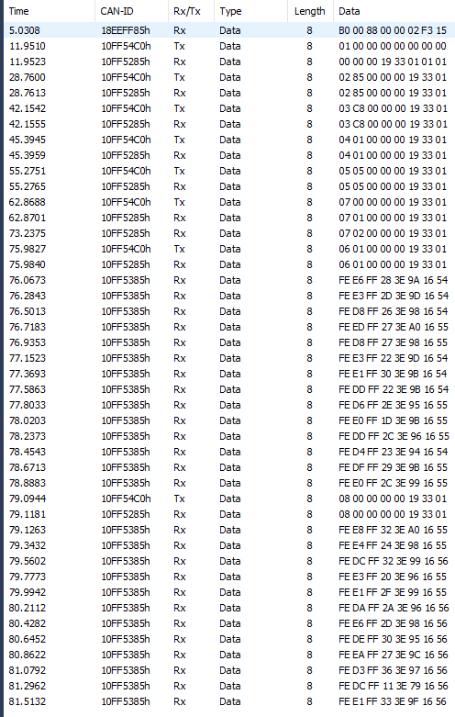

***Figure –1: Sample sequences of command and response messages captured by using Peak-CAN analyzer***

After saving the configuration into non-volatile memory, it is always working on these configurations until you change and save them.

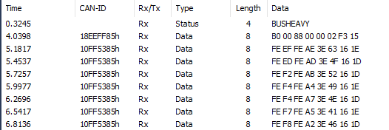

***Figure –2: Sample data captured by using Peak-CAN analyzer***

# Qualification and test

# Packing

# Additional information